POLOVIŠTE DUŽINE I INTERVAL U KOORDINATNOM SUSTAVU NA PRAVCU
21.
a) $x_{P}=\frac{x_{A}+x_{B}}{2}=\frac{-22+86}{2}=32$ P(32)
b) $x_{P}=\frac{x_{A}+x_{B}}{2}=\frac{-4.8-2.7}{2}=-3.75$ P(-3.75)
c) $x_{P}=\frac{x_{A}+x_{B}}{2}=\frac{-5\frac{1}{4}+12\frac{2}{3}}{2}=\frac{\frac{89}{12}}{\frac{2}{1}}=\frac{89}{24}$ P($\frac{89}{24}$)
d) $x_{P}=\frac{x_{A}+x_{B}}{2}=\frac{35.8-17\frac{7}{8}}{2}=\frac{35.8-17.875}{2}=\frac{17.925}{2}=8.9625$ P($8.9625$)

22.
a) $x_{P}=\frac{x_{A}+x_{B}}{2}$ $x_{B}=2x_{P}-x_{A}=2·50-(-25)=100+25=125$
B(125)
b) $x_{P}=\frac{x_{A}+x_{B}}{2}$ $x_{A}=2x_{P}-x_{B}=2·\left(-2.2\right)-\left(-0.7\right)=-4.4+0.7=-3.7$
A(-3.7)
c) ) $x_{P}=\frac{x_{A}+x_{B}}{2}$ $x_{B}=2x_{P}-x_{A}=2·4\frac{1}{2}-\left(-3\frac{3}{4}\right)=9+3\frac{3}{4}=12\frac{3}{4}$
B(12 $\frac{3}{4}$)
d) ) $x_{P}=\frac{x_{A}+x_{B}}{2}$ $x_{A}=2x_{P}-x_{B}=2·\left(-20\right)-\left(-12\frac{3}{8}\right)=-40+12\frac{3}{8}=-27\frac{5}{8}$
A($-27\frac{5}{8}$)

23.
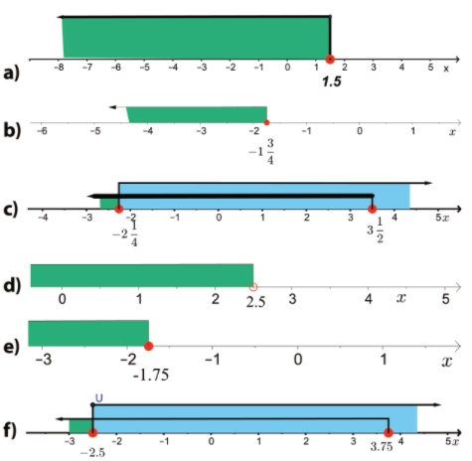

24.
a)$x ∈ 〈-3.5,1.5〉, z ∈\{-3,-2,-1,0,1\}$
b) $x ∈ \left[-4,\left.3\right\rangle \right., z ∈\{-4,-3,-2,-1,0,1,2\}$
c)$x ∈ \left\langle -2\right.,\left.5\right], z ∈\{-1,0,1,2,3,4,5\}$
d)$x ∈ \left\langle -∞\right., \left.1.5\right], z ∈\{…,-3,-2,-1,0,1\}$
e)$x ∈ 〈-2.5, ∞〉, z ∈\{-2,-1,0,1,2,…\}$

25.
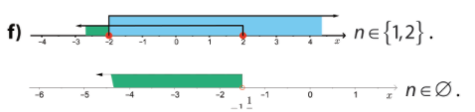
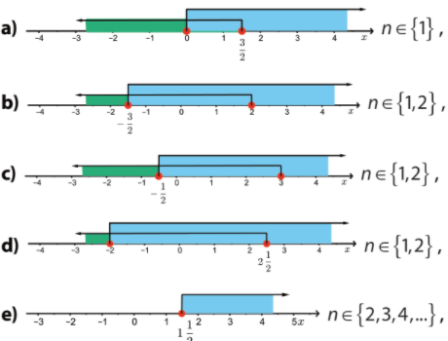

26.
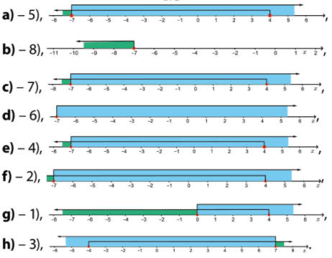
27.
NEJEDNADŽBA | INTERVAL
3 < x < 8 | $$x ∈〈3,8〉$$
-0.5 <x ≤6.5 | $$x∈\left\langle -0.5, \right.\left.6.5\right]$$
x > 8 | $$x ∈〈8,∞〉$$
$$-\frac{3}{4}≤x<1\frac{1}{2}$$ | $$x∈\left[-\frac{3}{4}\right.,\left.1\frac{1}{2}\right\rangle$$
$$x ≤-\frac{5}{6}$$ | $$x∈\left\langle -∞,\left.-\frac{5}{6}\right]\right.$$
$$-5<x≤3\frac{1}{2}$$ | $$x∈\left\langle -5,\left.3\frac{1}{2}\right]\right.$$
$$-2≤x≤2$$ | $$x∈\left[-2,2\right]$$

28.
a) 7)
b) 1)
c) 6)
d) 8)
e) 4)
f) 3)
g) 2)
h) 5)

29.
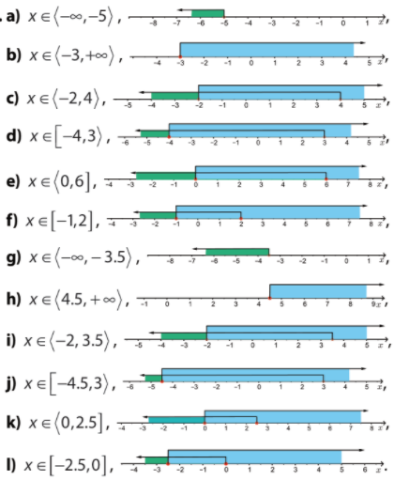

30.
a) $z∈\{1\}$
b)$z∈\{-1,0,1,2\}$
c) $z∈\{0,1,2\}$
d) $z∈\{-1,0,1,2\}$
e) $z∈\{2,3,4,…\}$
f) $z∈\{…,-4,-3,-2\}$

31.
a)$1 ∈[-4,5]$
b)$1∉〈6,∞〉$
c) $1 ∈\left[\frac{1}{2}\right.,\left.\frac{11}{5}\right\rangle$
d) $1 ∈〈-7.5,∞〉$
e) $1 ∈\left\langle -0.45,\right.\left.\frac{5}{3}\right]$
f) $1∉〈3,\frac{9}{2}〉$
g) $1∉\left[-7,\right.\left.0\right\rangle$
h) $1∉〈3,-2〉$

32.
a) $-7∈[-7,4]$
b) $-7∉〈-∞,-7〉$
c) $-7∈[-7,\left.4\right\rangle$
d) $-7∉〈-7,-∞〉$
e) $-7∈[-7,\left.4\right\rangle$
f) $-7∉〈-7,4〉$
g) $-7∈[-4,\left.0\right\rangle$
h)$-7∉〈-4,7〉$

33.
Koordinate točaka su: $X\left(-2\frac{2}{3}\right),Y\left(-1\frac{1}{3}\right), Z\left(-\frac{1}{3}\right), P\left(\frac{2}{3}\right), R\left(1\frac{2}{3}\right),S\left(2\frac{1}{3}\right)$
INTERVAL | TOČKE KOJE MU PRIPADAJU
$$〈-∞,1〉$$ | X,Y,Z,P
$$\left\langle -2,\left.2\right]\right.$$ | Y,Z,P,R
$$\left[-1, \right.\left.3\right\rangle$$ | Z,P,R,S
$$\left\langle -3,\left.-1\right]\right.$$ | X,Y
$$\left[-1\frac{2}{3}, \right.\left.1\frac{1}{3}\right\rangle$$ | Y,Z,P
$$\left\langle -\frac{2}{3},\left.\frac{5}{3}\right]\right.$$ | Z,P,R
$$\left[-1\frac{1}{3}, \right.\left.+∞\right\rangle$$ | Y,Z,P,R,S

34.
Koordinate točaka su: $X\left(-2\frac{1}{2}\right),Y\left(-1\frac{1}{4}\right), Z\left(-\frac{1}{2}\right),O\left(0\right), P\left(\frac{1}{4}\right), R\left(1\frac{1}{2}\right),S\left(2\frac{3}{4}\right)$
INTERVAL | TOČKE KOJE MU PRIPADAJU
$$〈-2,1〉$$ | Y,Z,O,P
$$\left\langle -1\frac{1}{2},\left.1\frac{1}{2}\right]\right.$$ | Y,Z,O,P,R
$$\left[-\frac{3}{4}, \right.\left.2\right\rangle$$ | Z,O,P,R
$$\left\langle -1,\left.2\frac{3}{4}\right]\right.$$ | Z,O,P,R,S
$$\left[-1\frac{1}{4}, \right.\left.1\frac{1}{2}\right\rangle$$ | Y,Z,O,P
$$\left\langle -\frac{5}{4},\left.\frac{3}{2}\right]\right.$$ | Z,O,P,R
$$\left[-1\frac{1}{4}, \right.\left.+∞\right\rangle$$ | Y,Z,O,P,R,S

35.
Koordinate točaka su: $X\left(-2\frac{2}{5}\right),Y\left(-1\frac{4}{5}\right), Z\left(-1\frac{1}{5}\right), P\left(-\frac{2}{5}\right),O\left(0\right), R\left(\frac{3}{5}\right),S\left(1\frac{4}{5}\right)$
INTERVAL | TOČKE KOJE MU PRIPADAJU
$$〈-∞,\frac{3}{5}〉$$ | X,Y,Z,P,O
$$\left\langle -2,\left.-\frac{1}{5}\right]\right.$$ | Y,Z, P
$$\left[-1, \right.\left.\frac{4}{5}\right\rangle$$ | P,O,R
$$\left\langle -3,\left.\frac{1}{5}\right]\right.$$ | X,Y,Z,P,O
$$\left[-\frac{2}{5}, \right.\left.1\frac{3}{5}\right\rangle$$ | P,O,R
$$\left\langle -\frac{1}{5},\left.2\frac{1}{5}\right]\right.$$ | O,R,S
$$\left[\frac{1}{5}, \right.\left.+∞\right\rangle$$ | R,S

36.
1) $A,C,D,F ∈\left[-1\frac{2}{3},\right.\left.1\frac{1}{3}\right\rangle$
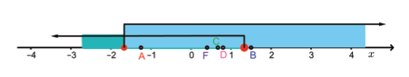
2) $B,C,D,F ∈\left\langle -\frac{2}{3}\right.,\left.\frac{5}{3}\right]$
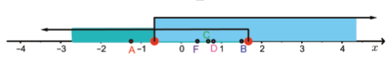
3) $A,C,D,F ∈\left[-1\frac{1}{4},\right.\left.1\frac{1}{2}\right\rangle$
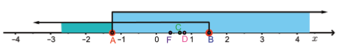
4) Nijedna točka nije u intervalu.
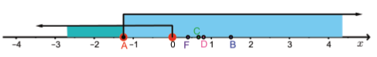
5) $B,C,D,F ∈\left[-\frac{2}{5},\right.\left.1\frac{3}{5}\right\rangle$
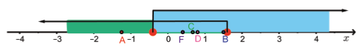
37. $-1,0,1,2 ∈\left[-2,\right.\left.\frac{5}{2}\right\rangle$

38.
a) $A∉ 〈0,\frac{3}{2}〉$
b) $A∈ \left[-\frac{3}{2},2\right]$
c) $A∈\left[-\frac{1}{2},\right.\left.3\right\rangle$
d)$A∈\left\langle -2\right.,2\left.\frac{1}{2}\right]$
e) $A∉ 〈1\frac{1}{2},+∞〉$
f) $A∈ \left[-2,2\right]$
g)$A∉ 〈-∞,-1\frac{1}{2}〉$

39.
a) $B∈ 〈-2,1〉$
b) $B∈ \left\langle -1\frac{1}{2}\right.,1\left.\frac{1}{2}\right]$
c) $B∉ 〈-\frac{3}{4},2〉$
d)$B∈\left\langle -1\right.,2\left.\frac{3}{4}\right]$
e) $B∉ \left[-\frac{1}{4},\right.\left.1\frac{1}{2}\right\rangle$
f) $B∉ \left\langle -\frac{1}{2}\right.,\left.\frac{3}{2}\right]$
g) $B∈ \left[-1\frac{1}{4},\right.\left.+∞\right\rangle$

40.
a) $C∉ 〈-∞,\frac{3}{5}〉$
b) $C∉ \left\langle -2\right.,-\left.\frac{1}{5}\right]$
c) $C∈ \left[-1,\right.\left.\frac{4}{5}\right\rangle$
d)$C∉\left\langle -3\right.,\left.\frac{1}{5}\right]$
e) $C∈ \left[-\frac{2}{5},\right.\left.1\frac{3}{5}\right\rangle$
f) $C∉ \left\langle -\frac{1}{5}\right.,\left.\frac{1}{5}\right]$
g) $C∈ \left[\frac{1}{5},\right.\left.+∞\right\rangle$

41.
a) $\left[-1.5,\right.\left.3.5\right\rangle$, $z∈\{-1,0,1,2,3\}$
b) $〈0.5,1〉,$ $z∈\{∅\}$
c) $\left\langle -1\right.,\left.4\right],$ , $z∈\{0,1,2,3,4\}$
d) $\left[-3,\right.\left.+∞\right\rangle$, $z∈\{-3,-2,-1,0,1,2,3,…\}$

42.
a) $x_{P}=\frac{x_{A}+x_{B}}{2}=\frac{12-5}{2}=3.5$ P(3.5)
b) $x_{P}=\frac{x_{A}+x_{B}}{2}=\frac{-22-4}{2}=-13$ P(-13)
c) $x_{P}=\frac{x_{A}+x_{B}}{2}=\frac{-\frac{4}{5}+1\frac{2}{3}}{2}=\frac{\frac{13}{15}}{\frac{2}{1}}=\frac{13}{30}$ P($\frac{13}{30}$)
d) $x_{P}=\frac{x_{A}+x_{B}}{2}=\frac{-12.32+5.13}{2}=\frac{-7.19}{2}=-3.595$ P($-3.595$)

43.
a) $x_{P}=\frac{x_{A}+x_{B}}{2}=\frac{-3.285+32.85}{2}=\frac{29.565}{2}=14.7825$ P($14.7825$)
b) $x_{P}=\frac{x_{A}+x_{B}}{2}=\frac{-3.35-1\frac{7}{8}}{2}=\frac{-3.35-1.875}{2}=-2.6125$ P($-2.6125$)
c) $x_{P}=\frac{x_{A}+x_{B}}{2}=\frac{6\frac{5}{12} -2\frac{3}{8}}{2}=\frac{\frac{97}{24}}{\frac{2}{1}}=\frac{97}{48}$ P($\frac{97}{48}$)
d) $x_{P}=\frac{x_{A}+x_{B}}{2}=\frac{-3.5-9\frac{3}{4}}{2}=\frac{-3.5-9.75}{2}=-6.625$ P($-6.625$)
44.
a) $x_{P}=\frac{x_{A}+x_{B}}{2}$ $x_{B}=2x_{P}-x_{A}=2·12-\left(-25\right)=24+25=49$
B(49)
b) $x_{P}=\frac{x_{A}+x_{B}}{2}$ $x_{A}=2x_{P}-x_{B}=2·\left(-12.5\right)-\left(-0.85\right)=-25+0.85=-24.15$
A(-24.15)
c) ) $x_{P}=\frac{x_{A}+x_{B}}{2}$ $x_{B}=2x_{P}-x_{A}=2·3\frac{5}{14}-\left(-2\frac{1}{7}\right)=\frac{47}{7}+\frac{15}{7}=\frac{62}{7}$
B(8 $\frac{6}{7}$)
d) $x_{P}=\frac{x_{A}+x_{B}}{2}$ $x_{A}=2x_{P}-x_{B}=2·\left(-4\frac{5}{6}\right)-\left(-3.2\right)=-\frac{29}{3}+\frac{16}{5}=-\frac{97}{15}$
A($-6\frac{7}{15}$)

